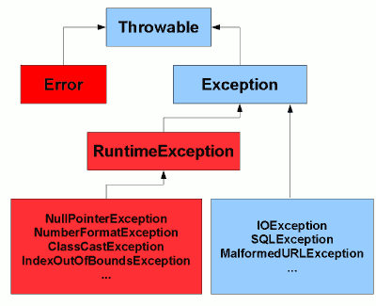

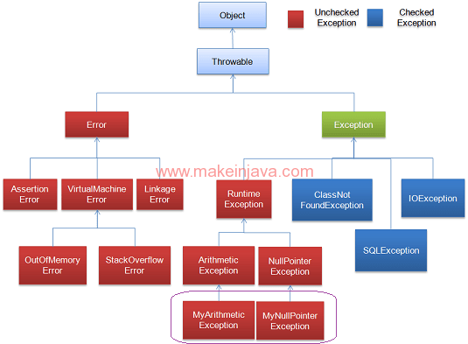

Types of Exception

There are mainly two types of exceptions: checked and unchecked where error is considered as unchecked exception. The sun microsystem says there are three types of exceptions:

1. Checked Exception
2. Unchecked Exception
3. Error

Difference between checked and unchecked exceptions

**1) Checked Exception**

The classes that extend Throwable class except RuntimeException and Error are known as checked exceptions e.g.IOException, SQLException etc. Checked exceptions are checked at compile-time.

If Compiler doesn’t see try or catch block handling a Checked Exception, it throws Compilation error.  
  
  
In certain situations Java Compiler forced the programmer to write an Exception handler at compile time, the Exceptions thrown in such situation are called Checked Exception, see the example below

plain print[?](http://www.beingjavaguys.com/2013/04/exception-handling-in-java-exception.html)

1. **try** {
2. String input = reader.readLine();
3. System.out.println("You typed : "+input); // Exception prone area
4. } **catch** (IOException e) {
5. e.printStackTrace();
6. }

While writing a code to read or write something from files or even from or to console, an checked Exception i.e. IOException is thrown, these exceptions are checked at compile time and we are forced to write a handler at compile time. That’s why we called these exceptions Checked Exceptions. We will know about try-catch and other Exception Handling stuff in next blog.

**Some common CheckedExceptions in Java**

Here is a list of some common Unchecked Exceptions in Java language.

IOException  
FileNotFoundException  
ParseException  
ClassNotFoundException  
CloneNotSupportedException  
InstantiationException  
InterruptedException  
NoSuchMethodException

**2) Unchecked Exception**

The classes that extend RuntimeException are known as unchecked exceptions e.g. ArithmeticException, NullPointerException, ArrayIndexOutOfBoundsException etc. Unchecked exceptions are not checked at compile-time rather they are checked at runtime.

**Some common Unchecked Exceptions in Java**

Here is a list of some common Unchecked Exceptions in Java language. ArithmeticException  
ArrayStoreException  
BufferOverflowException  
BufferUnderflowException  
CannotRedoException  
CannotUndoException  
ClassCastException  
CMMException  
ConcurrentModificationException  
DOMException  
EmptyStackException  
IllegalArgumentException  
IllegalMonitorStateException  
IllegalPathStateException  
IllegalStateException  
ImagingOpException  
IndexOutOfBoundsException  
MissingResourceException  
NegativeArraySizeException  
NoSuchElementException  
NullPointerException  
ProfileDataException  
ProviderException  
RasterFormatException  
SecurityException  
SystemException  
UndeclaredThrowableException  
UnmodifiableSetException  
UnsupportedOperationException

**3) Error**

Error is irrecoverable e.g. OutOfMemoryError, VirtualMachineError, AssertionError etc.